C ASSIGNMENT 3
Chetna Sharma A2305220076
QUES 1 Write a program to print power of a number using for loop
PROGRAM:
#include<stdio.h>
int main()
{
int base, exponent, i, power;

printf("Enter base: ");
scanf("%d",&base);

printf("Enter exponent: ");
scanf("%d", &exponent);
power = 1;

for(i=1; i<=exponent; i++)
power = power * base;

printf("Power : %d", power);
return 0;
}
OUTPUT:
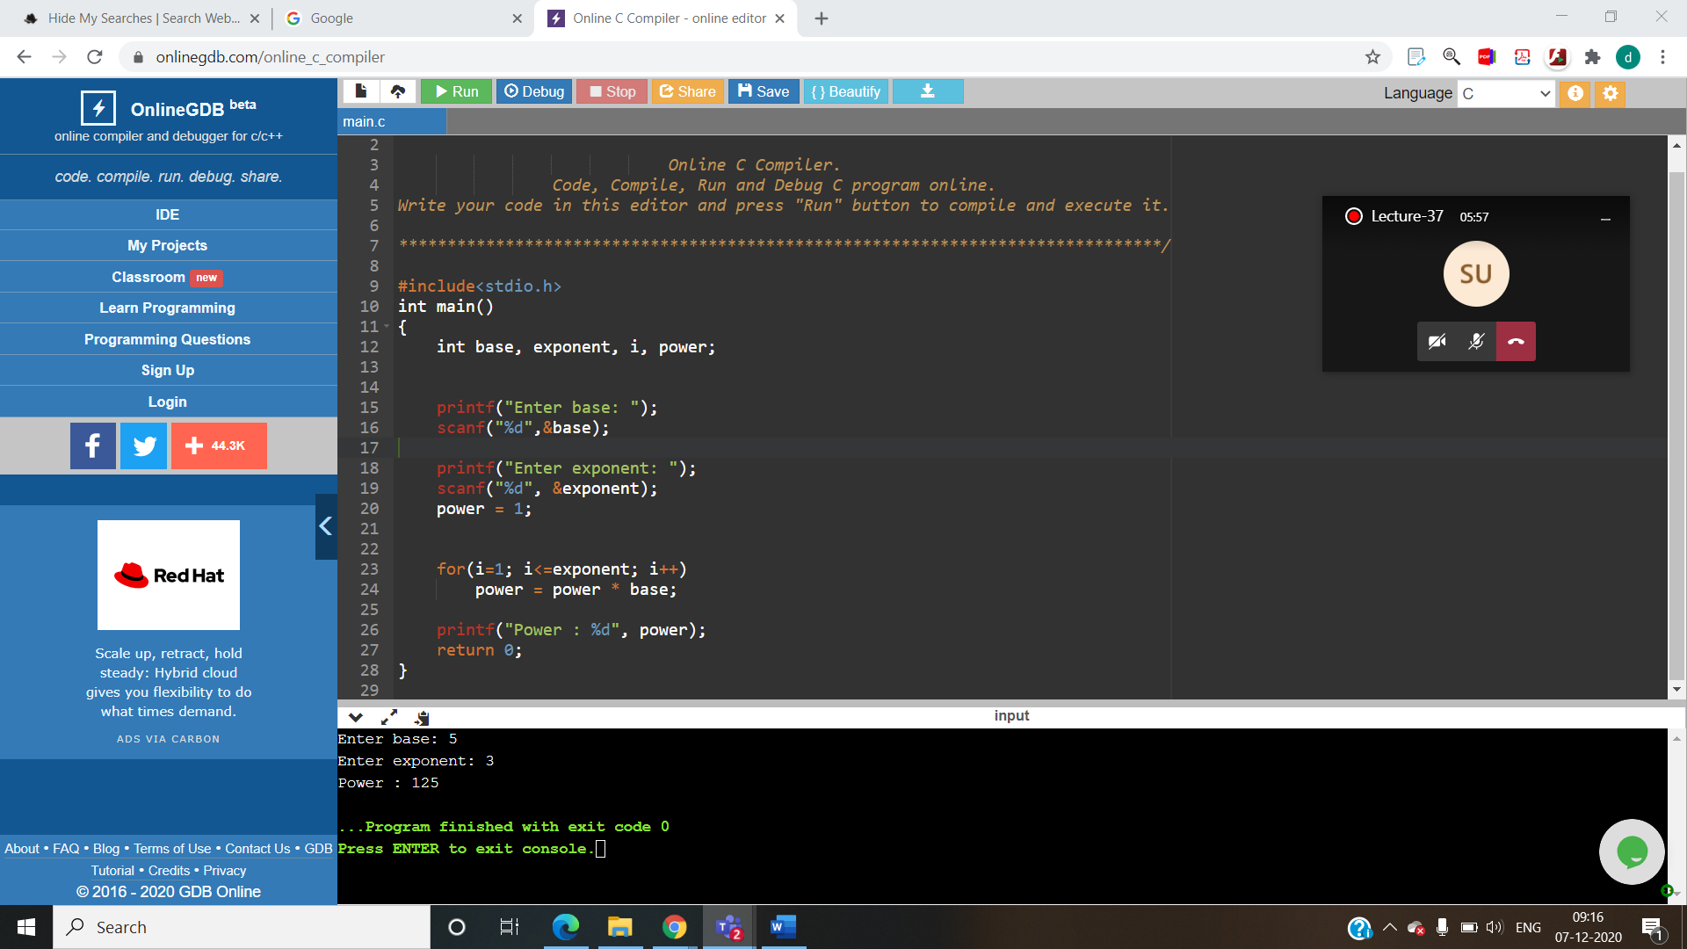

QUES 2:Write a c program to find all factors of a number.
PROGRAM:
#include <stdio.h>
int main() {
int num, i;
printf("Enter a positive integer: ");
scanf("%d", &num);
printf("Factors of %d are: ", num);
for (i = 1; i <= num; ++i) {
if (num % i == 0) {
printf("%d ", i);
}
}
return 0;
}
OUTPUT:
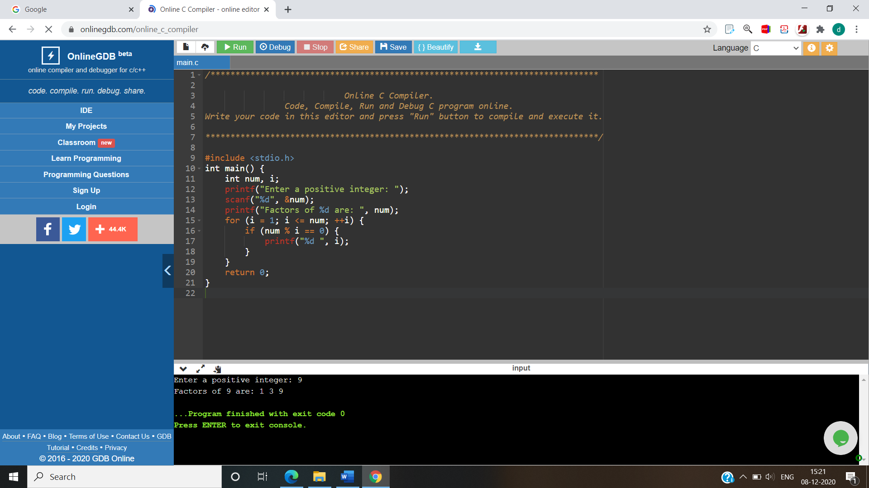

QUES 3: Write a c program to find HCF(GCD0 of two numbers.
Program:
#include <stdio.h>
int main()
{
int n1, n2, i, gcd;

printf("Enter two integers: ");
scanf("%d %d", &n1, &n2);

for(i=1; i <= n1 && i <= n2; ++i)
{

if(n1%i==0 && n2%i==0)
gcd = i;
}

printf("G.C.D of %d and %d is %d", n1, n2, gcd);

return 0;
}
OUTPUT:
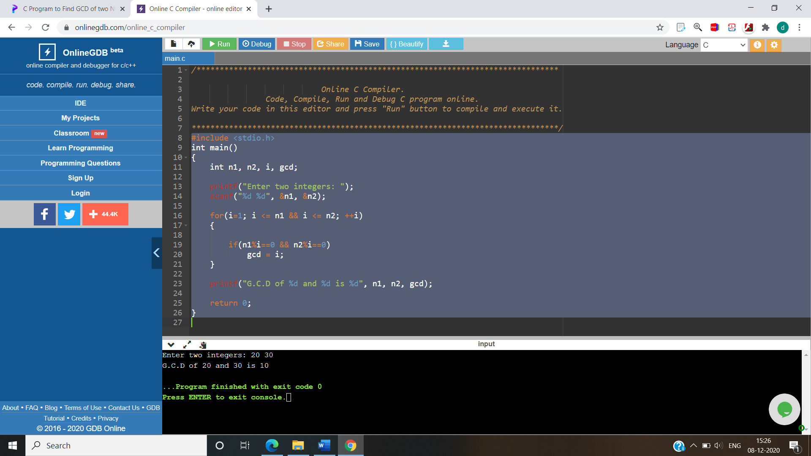

QUES 4 : Write a C program to find LCM of two numbers.
PROGRAM:
#include <stdio.h>

int main()
{
int Num1, Num2, max_Value;

printf("Please Enter two integer Values \n");
scanf("%d %d", &Num1, &Num2);

max_Value = (Num1 > Num2)? Num1 : Num2;

while(1)
{
if(max_Value % Num1 == 0 && max_Value % Num2 == 0)
{
printf("LCM of %d and %d = %d", Num1, Num2, max_Value);
break;
}
++max_Value;
}
return 0;
}
OUTPUT:
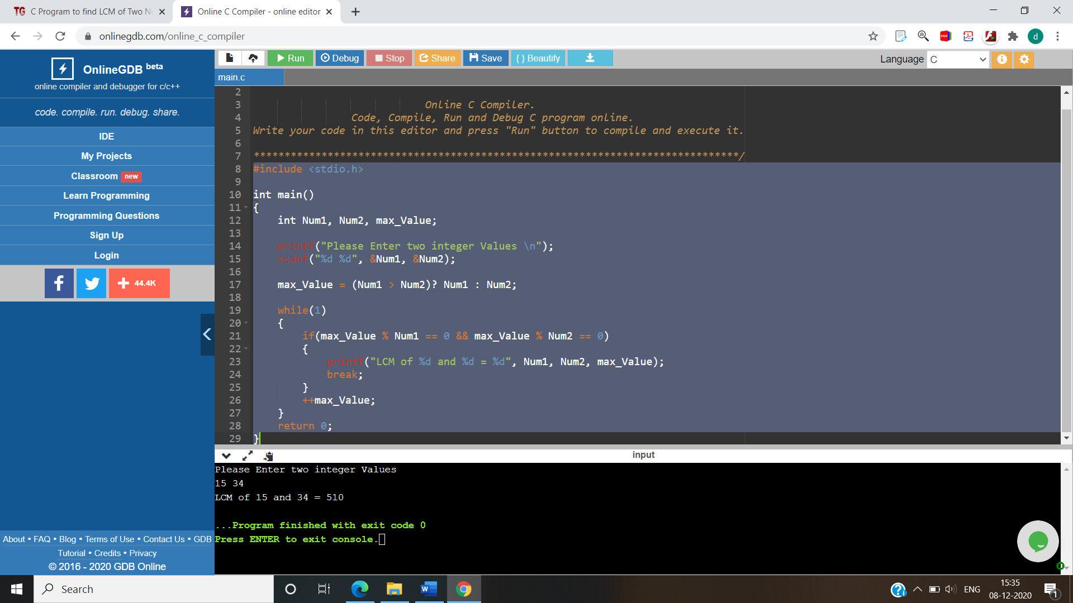

QUES 5: Wite a c program to find all prime factors of a number.
PROGRAM:

#include <stdio.h>

int main()
{
int i, j, Number, isPrime;

printf("\n Please Enter any number to Find Factors : ");
scanf("%d", &Number);

for (i = 2; i <= Number; i++)
{
if(Number % i == 0)
{
isPrime = 1;
for (j = 2; j <= i/2; j++)
{
if(i % j == 0)
{
isPrime = 0;
break;
}
}
if(isPrime == 1)
{
printf("\n %d is a Prime Factor ", i);
}
}
}
return 0;
}
OUTPUT:
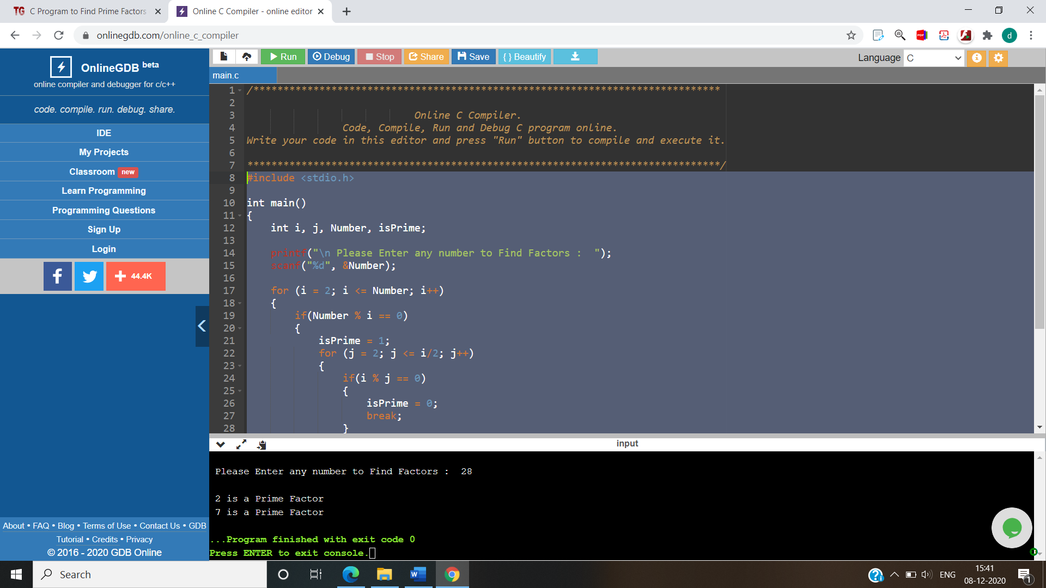
QUES 6:
Write a C program to check whether a number is strong number or not.
PROGRAM:
#include <stdio.h>
int main()
{
int n;
int sum=0;
printf("Enter a number");
scanf("%d",&n);
int k=n;
int r;
while(k!=0)
{
r=k%10;
int f=fact(r);
k=k/10;
sum=sum+f;
}
if(sum==n)
{
printf("\nNumber is a strong");
}
else
{
printf("\nNumber is not a strong");
}
return 0;
}
int fact(int r)
{
int mul=1;
for(int i=1;i<=r;i++)
{
mul=mul*i;
}
return mul;

}
OUTPUT:
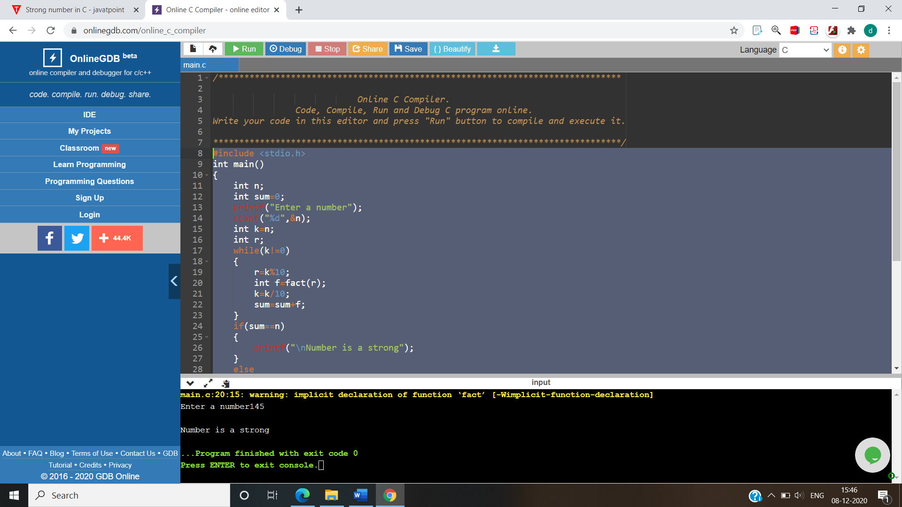

QUES 7 : Write a C program to print all strong numbers from 1 to n.
PROGRAM:
#include<stdio.h>
int main()
{
int fact=1,sum=0;
int n,r;
printf("Enter the 'n' number");
scanf("%d",&n);
printf("\n Strong numbers are :");
for(int i=1;i<=n;i++)
{
int k=i;
while(k!=0)
{
r=k%10;
fact=factorial(r);

k=k/10;
sum=sum+fact;
}
if(sum==i){
printf("%d, ",i);

}
sum=0;
}

return 0;
}

int factorial(int f)
{
int mul=1;
for(int i=1; i<=f;i++)
{
mul=mul*i;
}
return mul;
}
OUTPUT:
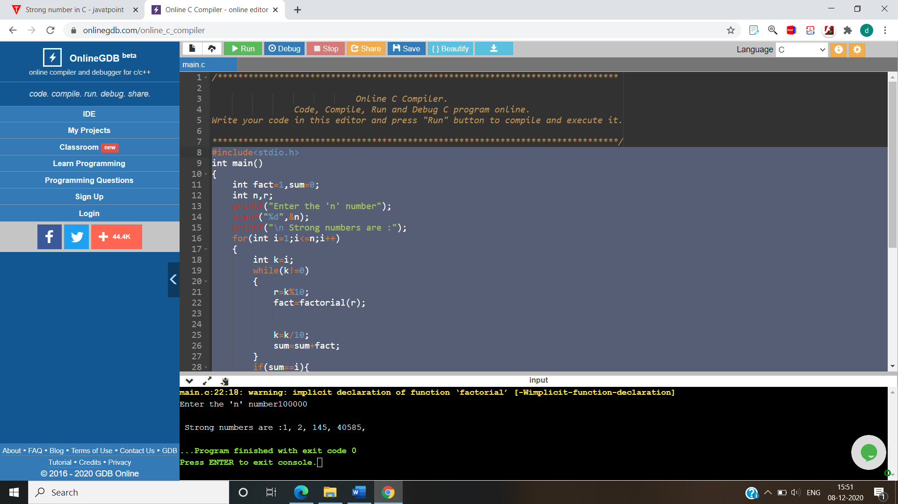

QUES 8: Write a C program to convert a hexadecimal to decimal number system.
PROGRAM:
#include <stdio.h>
int main()
{
char hex[17];
long decimal, place;
int i = 0, val, len;
decimal = 0;
place = 1;
printf("Enter any hexadecimal number: ");
gets(hex);
len = strlen(hex);
len--;
for(i=0; hex[i]!='\0'; i++)
{
if(hex[i]>='0' && hex[i]<='9')
{
val = hex[i] - 48;
}
else if(hex[i]>='a' && hex[i]<='f')
{
val = hex[i] - 97 + 10;
}
else if(hex[i]>='A' && hex[i]<='F')
{
val = hex[i] - 65 + 10;
}

decimal += val * pow(16, len);
len--;
}
printf("Hexadecimal number = %s\n", hex);
printf("Decimal number = %lld", decimal);
return 0;
}
OUTPUT:
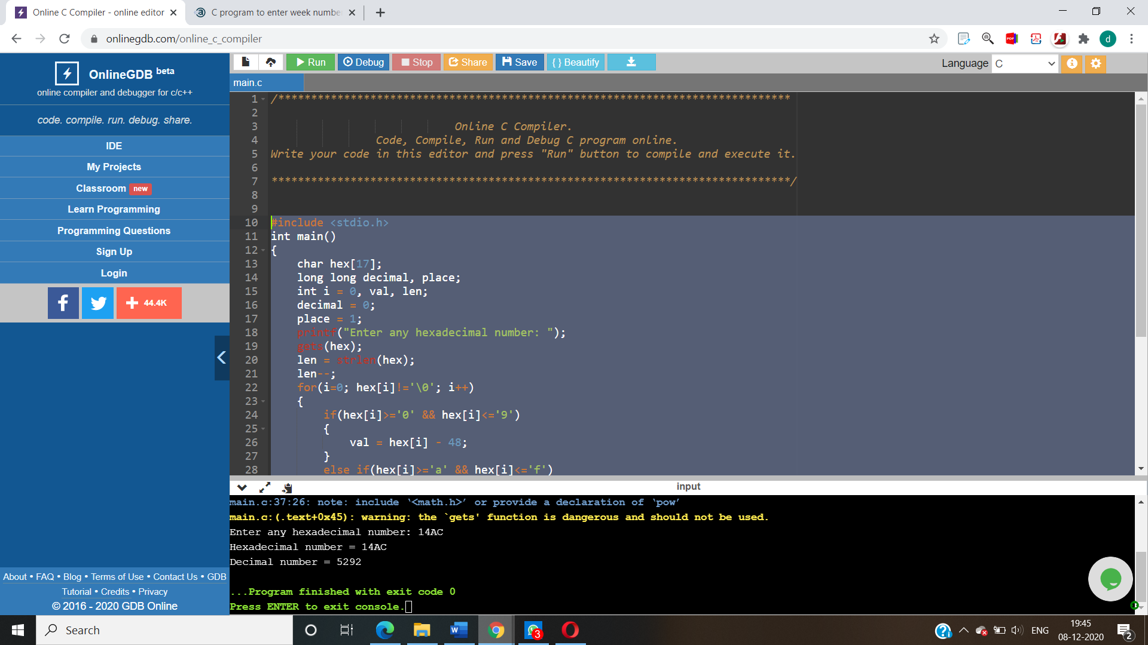
QUES 9: Write a C program to input week number and print week day.
PROGRAM:
#include <stdio.h>
int main()
{
unsigned int week;
//Ask user to input week number
printf("Enter week number (1-7): ");
scanf("%u", &week);
if(week == 1)
{
printf("Monday");
}
else if(week == 2)
{
printf("Tuesday");
}
else if(week == 3)
{
printf("Wednesday");
}
else if(week == 4)
{
printf("Thursday");
}
else if(week == 5)
{
printf("Friday");
}
else if(week == 6)
{
printf("Saturday");
}
else if(week == 7)
{
printf("Sunday");
}
else
{
printf("Invalid Input! Please enter week number between 1-7.");
}
return 0;
}
OUTPUT:

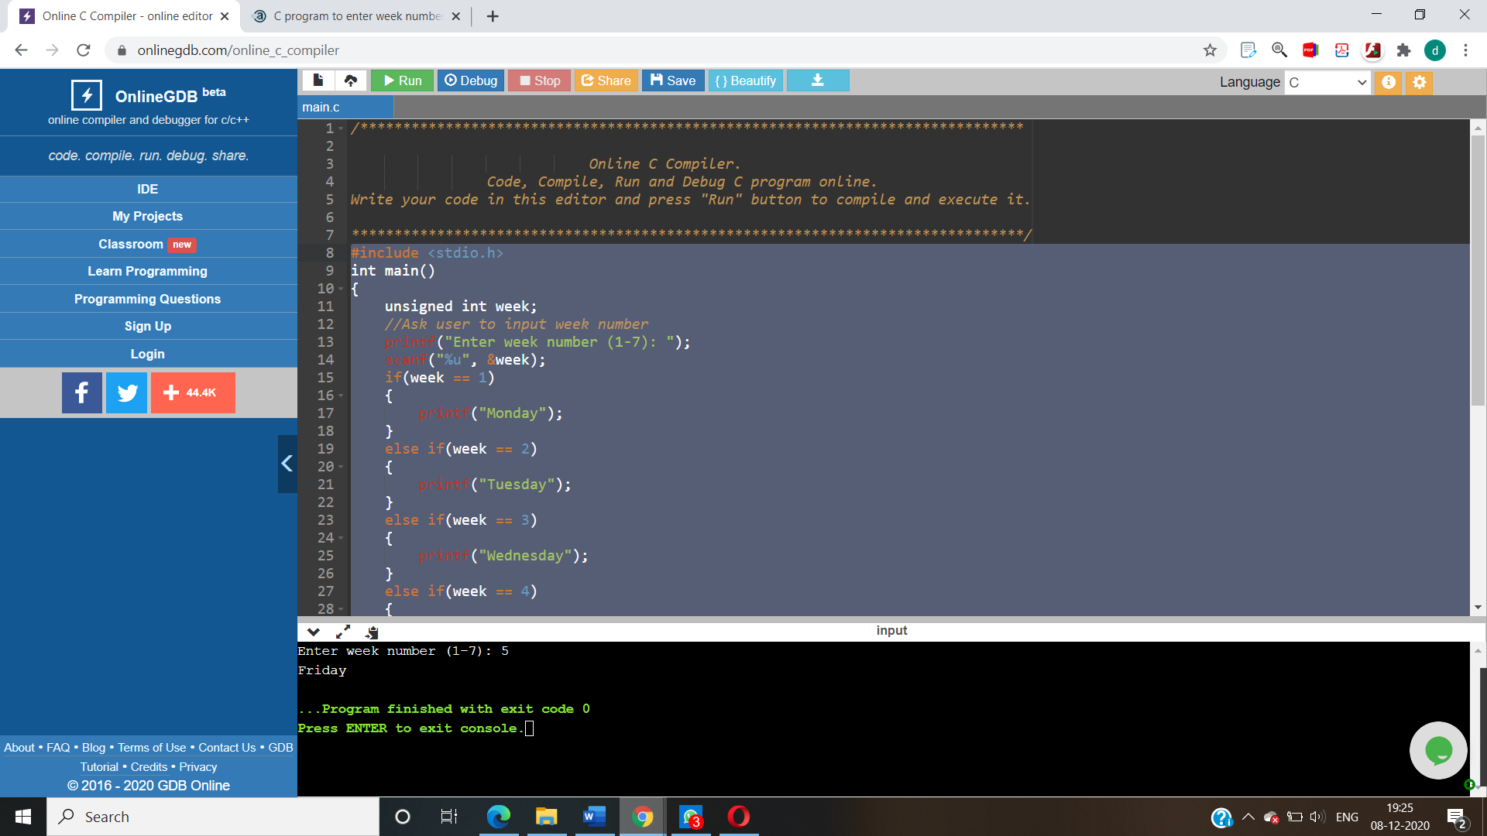

QUES 10: 10. Write a C program to input marks of five subjects Physics, Chemistry, Biology, Mathematics and Computer. Calculate percentage and grade according to following:
Percentage >= 90% : Grade A
Percentage >= 80% : Grade B
Percentage >= 70% : Grade C
Percentage >= 60% : Grade D
Percentage >= 40% : Grade E
Percentage < 40% : Grade F

PROGRAM:
#include <stdio.h>

int main()
{
int phy, chem, bio, math, comp;
float per;

printf("Enter five subjects marks: ");
scanf("%d%d%d%d%d", &phy, &chem, &bio, &math, &comp);

per = (phy + chem + bio + math + comp) / 5.0;

printf("Percentage = %.2f\n", per);

if(per >= 90)
{
printf("Grade A");
}
else if(per >= 80)
{
printf("Grade B");
}
else if(per >= 70)
{
printf("Grade C");
}
else if(per >= 60)
{
printf("Grade D");
}
else if(per >= 40)
{
printf("Grade E");
}
else
{
printf("Grade F");
}

return 0;
}
OUTPUT:

